SUKHPREET JENA
SUPERSET ID:- 6399056

Spring Rest HandsOn
Hands on 1
Create a Spring Web Project using Maven
pom.xml

<?xml version="1.0" encoding="UTF-8"?>
<project xmlns="http://maven.apache.org/POM/4.0.0" xmlns:xsi="http://www.w3.org/2001/XMLSchema-instance"
xsi:schemaLocation="http://maven.apache.org/POM/4.0.0 https://maven.apache.org/xsd/maven-4.0.0.xsd">
<modelVersion>4.0.0</modelVersion>
<parent>
<groupId>org.springframework.boot</groupId>
<artifactId>spring-boot-starter-parent</artifactId>
<version>3.5.3</version>
<relativePath/> <!-- lookup parent from repository -->
</parent>
<groupId>com.cognizant</groupId>
<artifactId>spring-learn</artifactId>
<version>0.0.1-SNAPSHOT</version>
<name>spring-learn</name>
<description>Demo project for learning Spring</description>
<url/>
<licenses>
<license/>
</licenses>
<developers>
<developer/>
</developers>
<scm>
<connection/>
<developerConnection/>
<tag/>
<url/>
</scm>
<properties>
<java.version>17</java.version>
</properties>
<dependencies>
<dependency>
<groupId>org.springframework.boot</groupId>
<artifactId>spring-boot-starter-web</artifactId>
</dependency>

<dependency>
<groupId>org.springframework.boot</groupId>
<artifactId>spring-boot-devtools</artifactId>
<scope>runtime</scope>
<optional>true</optional>
</dependency>
<dependency>
<groupId>org.springframework.boot</groupId>
<artifactId>spring-boot-starter-test</artifactId>
<scope>test</scope>
</dependency>
</dependencies>

<build>
<plugins>
<plugin>
<groupId>org.springframework.boot</groupId>
<artifactId>spring-boot-maven-plugin</artifactId>
</plugin>
</plugins>
</build>

</project>

Folder structure:

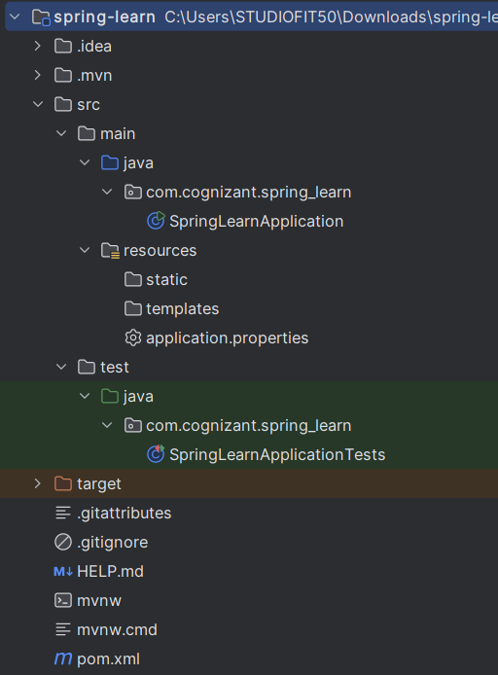

SpringLearnApplication.java

package com.cognizant.spring_learn;

import org.slf4j.Logger;
import org.slf4j.LoggerFactory;
import org.springframework.boot.SpringApplication;
import org.springframework.boot.autoconfigure.SpringBootApplication;

@SpringBootApplication
public class SpringLearnApplication {
private static final Logger LOGGER = LoggerFactory.getLogger(SpringLearnApplication.class);

public static void main(String[] args) {
SpringApplication.run(SpringLearnApplication.class, args);
LOGGER.info("Inside main()");
}
}

Output:

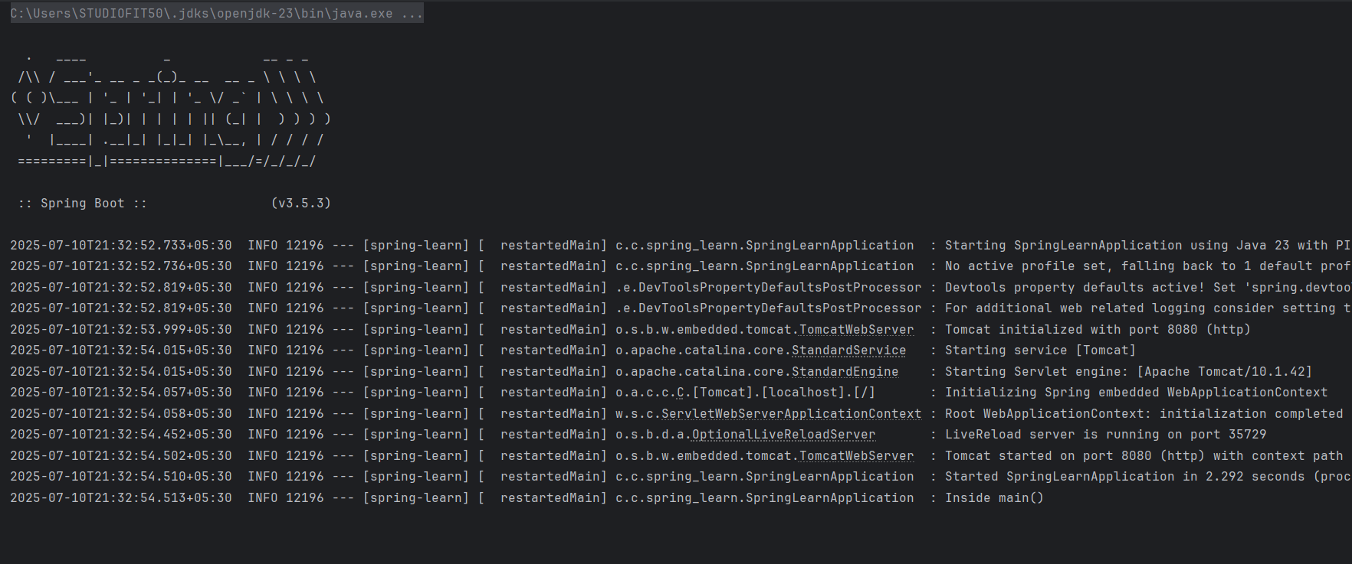

Hands on 2

Spring Core – Load SimpleDateFormat from Spring Configuration XML
src/main/resources/date-format.xml

<?xml version="1.0" encoding="UTF-8"?>
<beans xmlns="http://www.springframework.org/schema/beans"
xmlns:xsi="http://www.w3.org/2001/XMLSchema-instance"
xsi:schemaLocation="http://www.springframework.org/schema/beans
https://www.springframework.org/schema/beans/spring-beans.xsd">

<bean id="dateFormat" class="java.text.SimpleDateFormat">
<constructor-arg value="dd/MM/yyyy" />
</bean>

<!-- more bean definitions go here -->

</beans>

SpringLearnApplication.java

package com.cognizant.spring_learn;

import org.slf4j.Logger;
import org.slf4j.LoggerFactory;
import org.springframework.boot.SpringApplication;
import org.springframework.boot.autoconfigure.SpringBootApplication;
import org.springframework.context.ApplicationContext;
import org.springframework.context.support.ClassPathXmlApplicationContext;

import java.text.ParseException;
import java.text.SimpleDateFormat;
import java.util.Date;

@SpringBootApplication
public class SpringLearnApplication {
private static final Logger LOGGER = LoggerFactory.getLogger(SpringLearnApplication.class);

public static void main(String[] args) throws ParseException {
SpringApplication.run(SpringLearnApplication.class, args);
LOGGER.info("Inside main()");
System.out.println();
displayDate("31/12/2018");
}

public static void displayDate(String date) throws ParseException {
ApplicationContext context = new ClassPathXmlApplicationContext("date-format.xml");
SimpleDateFormat format = context.getBean("dateFormat", SimpleDateFormat.class);
Date inp = format.parse(date);
System.out.println("Parsed Date: " + inp);
}
}

Output:

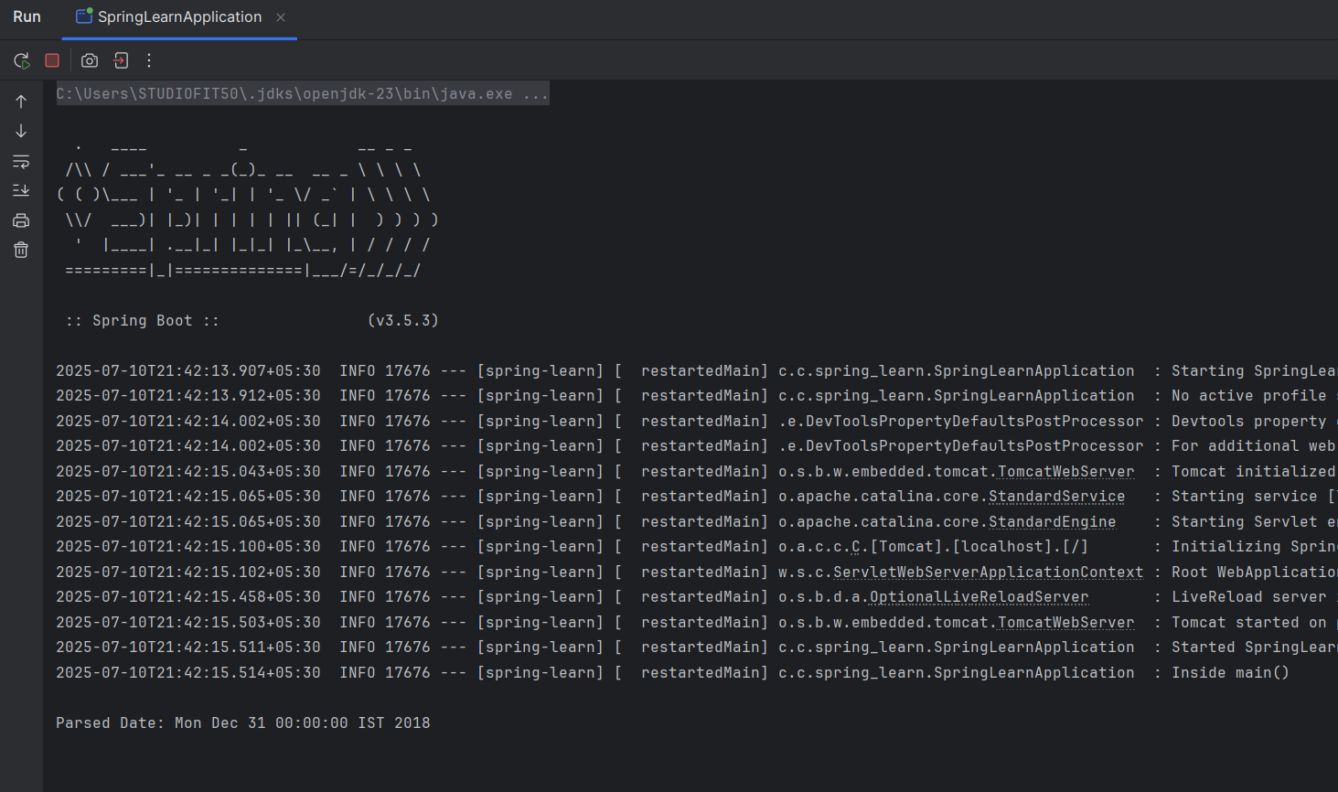

Hands on 3
Spring Core - Incorporate Logging
src/main/resources/application.properties

spring.application.name=spring-learn

logging.level.org.springframework=info
logging.level.com.cognizant.springlearn=debug
logging.pattern.console=%d{yyMMdd}|%d{HH:mm:ss.SSS}|%-20.20thread|%5p|%-25.25logger{25}|%25M|%m%n

SpringLearnApplication.java

package com.cognizant.springlearn;

import org.slf4j.Logger;
import org.slf4j.LoggerFactory;
import org.springframework.boot.SpringApplication;
import org.springframework.boot.autoconfigure.SpringBootApplication;
import org.springframework.context.ApplicationContext;
import org.springframework.context.support.ClassPathXmlApplicationContext;

import java.text.ParseException;
import java.text.SimpleDateFormat;
import java.util.Date;

@SpringBootApplication
public class SpringLearnApplication {
private static final Logger LOGGER = LoggerFactory.getLogger(SpringLearnApplication.class);

public static void main(String[] args) throws ParseException {
SpringApplication.run(SpringLearnApplication.class, args);
LOGGER.info("START");

Date date = displayDate("31/12/2018");
LOGGER.debug("Parsed Date = {}", date);

LOGGER.info("END");
}

public static Date displayDate(String date) throws ParseException {
ApplicationContext context = new ClassPathXmlApplicationContext("date-format.xml");
SimpleDateFormat format = context.getBean("dateFormat", SimpleDateFormat.class);
Date inp = format.parse(date);
return inp;
}
}

Output:
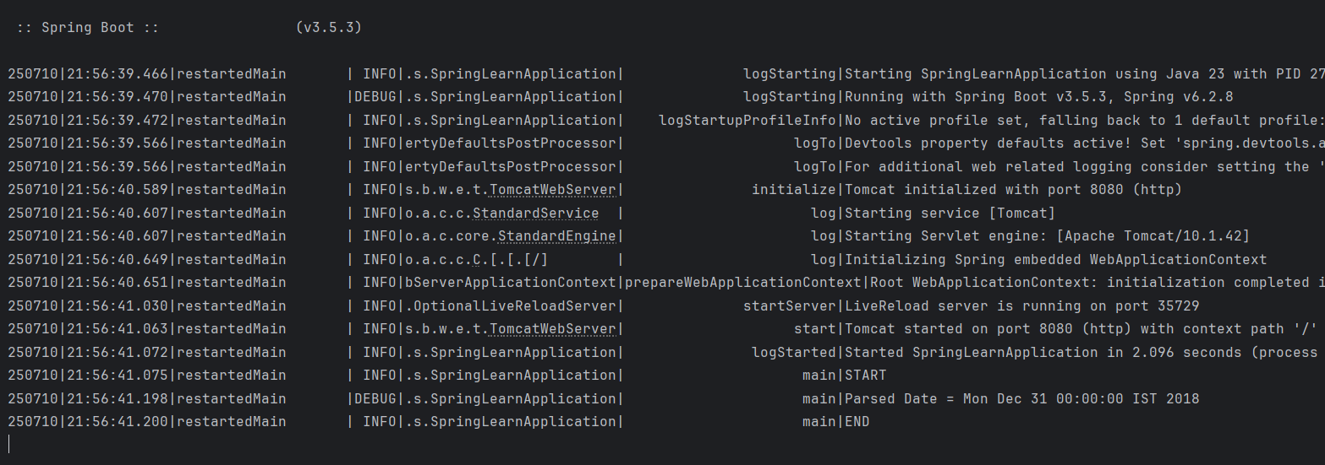

Hands on 4
Spring Core – Load Country from Spring Configuration XML

country.xml

<?xml version="1.0" encoding="UTF-8"?>
<beans xmlns="http://www.springframework.org/schema/beans"
xmlns:xsi="http://www.w3.org/2001/XMLSchema-instance"
xsi:schemaLocation="http://www.springframework.org/schema/beans
https://www.springframework.org/schema/beans/spring-beans.xsd">

<bean id="country" class="com.cognizant.springlearn.Country">
<property name="code" value="IN" />
<property name="name" value="India" />
</bean>

</beans>

Country.java

package com.cognizant.springlearn;

import org.slf4j.Logger;
import org.slf4j.LoggerFactory;

public class Country {
private static final Logger LOGGER = LoggerFactory.getLogger(Country.class);

private String code;
private String name;

public Country() {
LOGGER.debug("Inside Country Constructor");
}

public String getCode() {
LOGGER.debug("Inside getCode");
return code;
}

public void setCode(String code) {
LOGGER.debug("Inside setCode");
this.code = code;
}

public String getName() {
LOGGER.debug("Inside getName");
return name;
}

public void setName(String name) {
LOGGER.debug("Inside setName");
this.name = name;
}

@Override
public String toString() {
return "Country [code=" + code + ", name=" + name + "]";
}
}

SpringLearnApplication.java

package com.cognizant.springlearn;

import org.slf4j.Logger;
import org.slf4j.LoggerFactory;
import org.springframework.boot.SpringApplication;
import org.springframework.boot.autoconfigure.SpringBootApplication;
import org.springframework.context.ApplicationContext;
import org.springframework.context.support.ClassPathXmlApplicationContext;

import java.text.ParseException;
import java.text.SimpleDateFormat;
import java.util.Date;

@SpringBootApplication
public class SpringLearnApplication {
private static final Logger LOGGER = LoggerFactory.getLogger(SpringLearnApplication.class);

public static void main(String[] args) throws ParseException {
SpringApplication.run(SpringLearnApplication.class, args);
LOGGER.info("START");

displayDate("31/12/2018");
displayCountry();

LOGGER.info("END");
}

public static void displayDate(String date) throws ParseException {
ApplicationContext context = new ClassPathXmlApplicationContext("date-format.xml");
SimpleDateFormat format = context.getBean("dateFormat", SimpleDateFormat.class);
Date inp = format.parse(date);
LOGGER.debug("Parsed Date = {}", inp);
}

public static void displayCountry() {
ApplicationContext context = new ClassPathXmlApplicationContext("country.xml");
Country country = context.getBean("country", Country.class);
LOGGER.debug("Country : {}", country.toString());
}

}

Output:

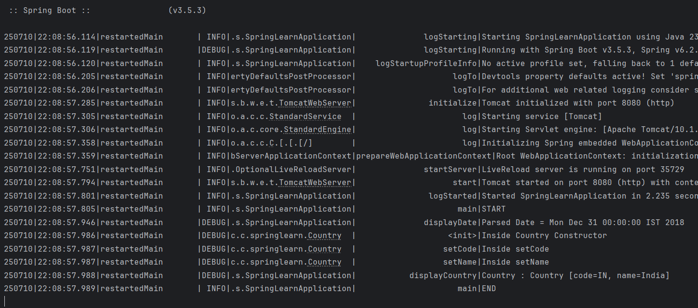

Hands on 5
Spring Core – Demonstration of Singleton Scope and Prototype Scope

SpringLearnApplication.java

package com.cognizant.springlearn;

import org.slf4j.Logger;
import org.slf4j.LoggerFactory;
import org.springframework.boot.SpringApplication;
import org.springframework.boot.autoconfigure.SpringBootApplication;
import org.springframework.context.ApplicationContext;
import org.springframework.context.support.ClassPathXmlApplicationContext;

import java.text.ParseException;
import java.text.SimpleDateFormat;
import java.util.Date;

@SpringBootApplication
public class SpringLearnApplication {
private static final Logger LOGGER = LoggerFactory.getLogger(SpringLearnApplication.class);

public static void main(String[] args) throws ParseException {
SpringApplication.run(SpringLearnApplication.class, args);
LOGGER.info("START");

displayDate("31/12/2018");
displayCountry();

LOGGER.info("END");
}

public static void displayDate(String date) throws ParseException {
ApplicationContext context = new ClassPathXmlApplicationContext("date-format.xml");
SimpleDateFormat format = context.getBean("dateFormat", SimpleDateFormat.class);
Date inp = format.parse(date);
LOGGER.debug("Parsed Date = {}", inp);
}

public static void displayCountry() {
ApplicationContext context = new ClassPathXmlApplicationContext("country.xml");
Country country = context.getBean("country", Country.class);
Country anotherCountry = context.getBean("country", Country.class);
LOGGER.debug("Country : {}", country.toString());
}

}

country.xml

<?xml version="1.0" encoding="UTF-8"?>
<beans xmlns="http://www.springframework.org/schema/beans"
xmlns:xsi="http://www.w3.org/2001/XMLSchema-instance"
xsi:schemaLocation="http://www.springframework.org/schema/beans
https://www.springframework.org/schema/beans/spring-beans.xsd">
<bean id="country" class="com.cognizant.springlearn.Country" scope="prototype">
<property name="code" value="IN" />
<property name="name" value="India" />
</bean>
</beans>

Output:

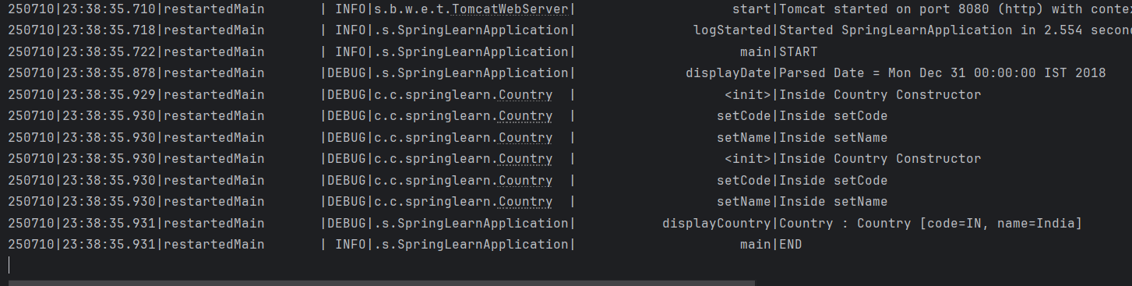

Hands on 6
Spring Core – Load list of countries from Spring Configuration XML

country.xml

<?xml version="1.0" encoding="UTF-8"?>
<beans xmlns="http://www.springframework.org/schema/beans"
xmlns:xsi="http://www.w3.org/2001/XMLSchema-instance"
xsi:schemaLocation="http://www.springframework.org/schema/beans
https://www.springframework.org/schema/beans/spring-beans.xsd">

<bean id="country" class="com.cognizant.springlearn.Country" scope="prototype">
<property name="code" value="IN" />
<property name="name" value="India" />
</bean>

<bean id="in" class="com.cognizant.springlearn.Country">
<property name="code" value="IN" />
<property name="name" value="India" />
</bean>

<bean id="us" class="com.cognizant.springlearn.Country">
<property name="code" value="US" />
<property name="name" value="United States" />
</bean>

<bean id="de" class="com.cognizant.springlearn.Country">
<property name="code" value="DE" />
<property name="name" value="Germany" />
</bean>

<bean id="jp" class="com.cognizant.springlearn.Country">
<property name="code" value="JP" />
<property name="name" value="Japan" />
</bean>

<bean id="countryList" class="java.util.ArrayList">
<constructor-arg>
<list>
<ref bean="in"></ref>
<ref bean="us"></ref>
<ref bean="de"></ref>
<ref bean="jp"></ref>
</list>
</constructor-arg>
</bean>

</beans>

SpringLearnApplication.java

package com.cognizant.springlearn;

import org.slf4j.Logger;
import org.slf4j.LoggerFactory;
import org.springframework.boot.SpringApplication;
import org.springframework.boot.autoconfigure.SpringBootApplication;
import org.springframework.context.ApplicationContext;
import org.springframework.context.support.ClassPathXmlApplicationContext;

import java.text.ParseException;
import java.text.SimpleDateFormat;
import java.util.ArrayList;
import java.util.Date;
import java.util.List;

@SpringBootApplication
public class SpringLearnApplication {
private static final Logger LOGGER = LoggerFactory.getLogger(SpringLearnApplication.class);

public static void main(String[] args) throws ParseException {
SpringApplication.run(SpringLearnApplication.class, args);
LOGGER.info("START main");

// displayDate("31/12/2018");
// displayCountry();
displayCountries();

LOGGER.info("END main");
}

public static void displayDate(String date) throws ParseException {
LOGGER.info("START displayDate");

ApplicationContext context = new ClassPathXmlApplicationContext("date-format.xml");
SimpleDateFormat format = context.getBean("dateFormat", SimpleDateFormat.class);
Date inp = format.parse(date);
LOGGER.debug("Parsed Date = {}", inp);

LOGGER.info("END displayDate");
}

public static void displayCountry() {
LOGGER.info("START displayCountry");

ApplicationContext context = new ClassPathXmlApplicationContext("country.xml");
Country country = context.getBean("country", Country.class);
Country anotherCountry = context.getBean("country", Country.class);
LOGGER.debug("Country : {}", country.toString());

LOGGER.info("END displayCountry");
}

public static void displayCountries() {
LOGGER.info("START displayCountries()");

ApplicationContext context = new ClassPathXmlApplicationContext("country.xml");
List<Country> countries = context.getBean("countryList", List.class);
LOGGER.debug("List of Countries: {}", countries);

LOGGER.info("END displayCountries()");
}

}
Output:

